<https://docs.google.com/document/d/1IUEAB_d2GgUxuc_QkuDvhz7aIiiAHLAU6msmI7M0A4A/edit?usp=sharing>

Step 1

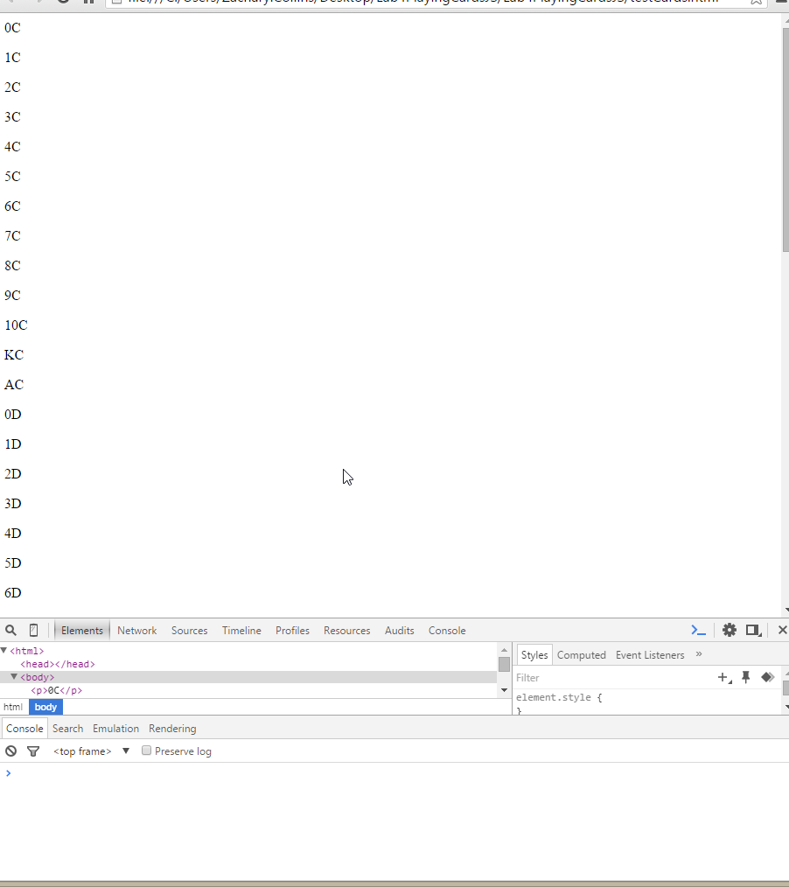

0C

1C

2C

3C

4C

5C

6C

7C

8C

9C

10C

KC

AC

0D

1D

2D

3D

4D

5D

6D

7D

8D

9D

10D

KD

AD

0H

1H

2H

3H

4H

5H

6H

7H

8H

9H

10H

KH

AH

0S

1S

2S

3S

4S

5S

6S

7S

8S

9S

10S

KS

AS

**Step 2**

